EXPERIMENT 2
FAMILIARIZATION OF DDL COMMANDS
AIM
To get familiarize with the Data Definition Language(DDL) like CREATE,ALTER,RENAME, TRUNCATE, DROP.
QUESTION
1.Create a database and a table with fields
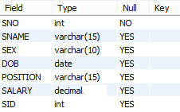
2.Insert some data using DML statement.
3. Add a column, Modify data type, Modify data type length, remove column, add constraint, remove constraint, show index, rename column/table.
4.Delete all rows at once.
5.Delete full structure of table.

SQL QUERIES
CREATE DATABASE DREAMHOME;
USE DREAMHOME;
CREATE TABLE STAFF(SNO INT NOT NULL,
SNAME VARCHAR(15),
SEX VARCHAR(10),
DOB DATE,
POSITION VARCHAR(15),
SALARY DECIMAL,
SID INTEGER
);
DESC STAFF;
INSERT INTO STAFF VALUE(1,'AMAL','MALE','1990-01-16','MANAGER',2000.56,1);
SELECT * FROM STAFF;
/*modify datatype*/
ALTER TABLE STAFF MODIFY SALARY DECIMAL(7,2);
INSERT INTO STAFF VALUE(2,'AJAY','MALE','1878-5-20','EMPLOYEE',12345.67,2);
/*add a column*/
ALTER TABLE STAFF ADD ADDRESS INT;
/*modify datatype*/
ALTER TABLE STAFF MODIFY ADDRESS VARCHAR(10);
/*modify datatype length*/
ALTER TABLE STAFF MODIFY ADDRESS VARCHAR(30);
/*remove column*/
ALTER TABLE STAFF DROP ADDRESS;
/*add constraint*/
ALTER TABLE STAFF ADD PRIMARY KEY(SNO);
/*To see the index*/
SHOW INDEXES FROM STAFF;
/*remove constraint*/
ALTER TABLE STAFF DROP PRIMARY KEY;
--constraint will be removed; column will be there.
/*add foreign key constraint*/
ALTER TABLE STAFF ADD CONSTRAINT fk1 FOREIGN KEY(SID) REFERENCES STAFF(SNO);
/*remove constraint*/
ALTER TABLE STAFF DROP FOREIGN KEY fk1;
/*it will be removed as foreign key, but still exists in index. So to remove it from showing in index use*/
ALTER TABLE STAFF DROP INDEX fk1;
/* After completing these steps, the foreign key and its associated index should no longer appear in the table's definition or index list.*/
/*rename column */
ALTER TABLE STAFF RENAME COLUMN SEX TO GENDER;
/*rename table*/
ALTER TABLE STAFF RENAME TO EMPLOYEE;
Or
RENAME TABLE old_table_name TO new_table_name;
/*Delete all rows at once*/
TRUNCATE EMPLOYEE;
SELECT * FROM EMPLOYEE;
/*Delete full structure of table*/
DROP TABLE EMPLOYEE;
DESC EMPLOYEE;
/*drop the entire database*/
DROP DATABASE DREAMHOME;

OUTPUT
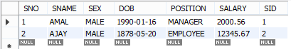

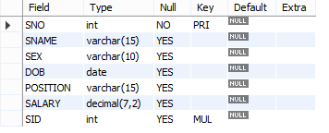
RESULT
Got familiarized with the Data Definition Language (DDL) like CREATE,ALTER,RENAME, TRUNCATE, DROP.

EXPERIMENT 3
CREATION OF DATABASE SCHEMA
AIM
Creation of database schema - DDL (create tables, set constraints, enforce relationships, create indices). Export ER diagram from the database and verify relationships.
QUESTION
STAFF

SNo | SName | Sex | DOB | Position | Salary | SID

BRANCH
BNo | BAddress | BTele | MID

OWNER
OID | OName | OAddress | OTele

WORKS
SID | BID

PROPERTY
PNo | Type | Rooms | Rent | PAddress | OID

CLIENT
CNo | CName | ReqType | MaxRent | BID

LEASE
PID | CID | MonthlyRent | Payment | Duration

GEN
RID | BID | RDate

USERRESP
RID | CID | Date | Comment

REPORT
PID | RID | Type | Rent | Address

SQL QUERIES
create database house;
use house;
create table Staff(SNo integer NOT NULL, SName varchar(15), Sex varchar(10), DOB date, Position varchar(15), Salary varchar(7), SID integer, primary key(SNo), foreign key(SID) references Staff(SNo));
create table Branch(BNo integer NOT NULL, BAddress varchar(30), BTele varchar(11), MID integer,primary key(BNo), foreign key(MID) references Staff(SNo));
create table Owner(OID integer NOT NULL, OName varchar(15), OAddress varchar(30), OTele varchar(11), primary key(OID));
create table Works(SID integer, BID integer, primary key(SID, BID));
create table Property(PNo integer NOT NULL, Type varchar(10), Rooms integer, Rent varchar(6),PAddress varchar(30), OID integer, primary key(PNo), foreign key(OID) references Owner(OID));
create table Client(CNo integer NOT NULL, CName varchar(15), ReqType varchar(10), MaxRent varchar(6), BID integer, primary key(CNo), foreign key(BID) references Branch(BNo));
create table Lease(PID integer NOT NULL, CID integer NOT NULL, MonthlyRent varchar(6), Payment varchar(10), Duration varchar(7), primary key(PID,CID), foreign key(PID) references Property(PNo), foreign key(CID) references Client(CNo));
create table Gen(RID integer NOT NULL, BID integer, RDate date, primary key(RID), foreign key(BID) references Branch(BNo));
create table UserResp(RID integer, CID integer, Date date, Comment varchar(50), primary key(RID,CID), foreign key(RID) references Gen(RID), foreign key(CID) references Client(CNo));
create table Report(PID integer, RID integer, Type varchar(6), Rent varchar(6), Address varchar(30), primary key(PID,RID), foreign key(PID) references Property(PNo), foreign key(RID) references Gen(RID));

To export ER Diagram:
DatabaseReverse EngineerStored Connection:Local instance MySQL80NextNextSelect the appropriate databaseNextNextExecuteNextFinish.
The EER (Enhanced Entity-Relationship) model in a DBMS is an extension of the original ER model that adds concepts to represent complex database structures more accurately.
OUTPUT
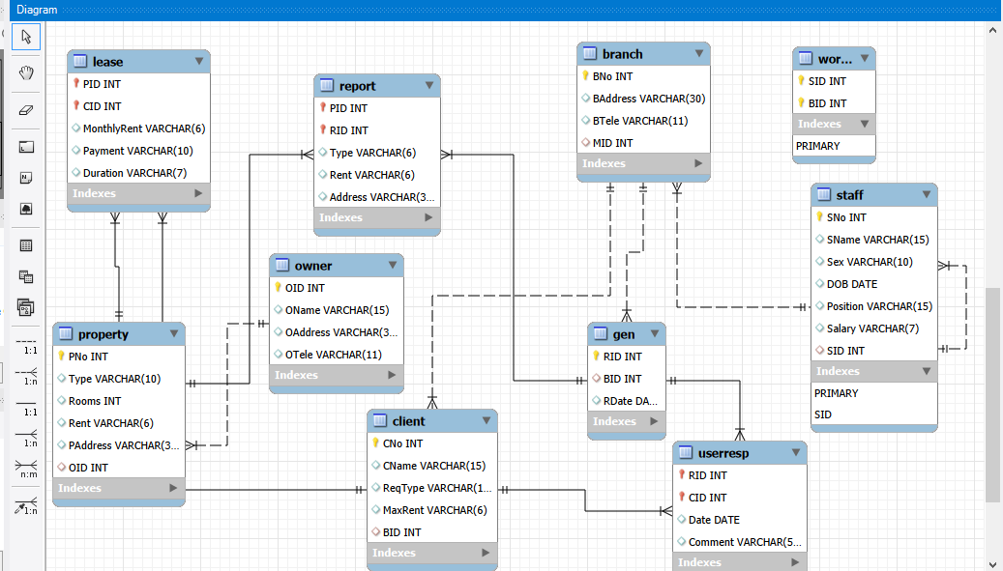

STAFF
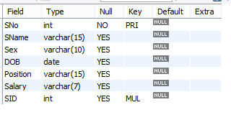
BRANCH
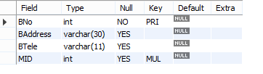
RESULT
Successfully created database schema using DDL commands and exported ER diagram using reverse engineering.

EXPERIMENT 4
DATABASE INITIALIZATION
AIM
Database initialization- Data insert, Data import to a database( bulk import using UI and SQL commands)
PROCEDURE
For this you can insert the desired data in an excel sheet and save it as csv file or you can download a csv file containing some data. Make sure the attribute name in the csv file should match the names in the table you are going to create.
NOTE: Keep the data in the csv file in correct format. Date should be in correct format(yyyy-mm-dd), no comma is allowed in number formats, VARCHAR should have enough length, email & website can be given VARCHAR,…etc….
CREATE DATABASE db1;
USE db1;
CREATE TABLE CUSTOMERS(Slno INT NOT NULL,
CustomerId VARCHAR(20),
FirstName VARCHAR(20),
LastName VARCHAR(20),
Company VARCHAR(50),
City VARCHAR(30),
Country VARCHAR(70),
Phone1 VARCHAR(30),
Phone2 VARCHAR(30),
Email VARCHAR(50),
SubscriptionDate DATE,
Website VARCHAR(50));
To find the location where the csv file should be saved:
SELECT @@secure_file_priv;
OR
SHOW VARIABLES LIKE "secure_file_priv";
You will get the location:
C:\ProgramData\MySQL\MySQL Server 8.0\Uploads\

Copy this location and find the location by pasting it in the search area of C drive. Save the csv file in that location.
LOAD DATA INFILE 'C:\\ProgramData\\MySQL\\MySQL Server 8.0\\Uploads\\abc.csv' INTO TABLE CUSTOMERS
FIELDS TERMINATED BY ','
IGNORE 1 LINES;
(The first line in csv file is ignored because it contain the attribute name. Data starts from second line).
SELECT * FROM CUSTOMERS;
OUTPUT
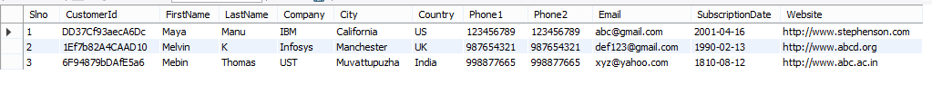
RESULT
Bulk import of data using SQL commands is successfully completed.

EXPERIMENT 5
PRACTICE SQL COMMANDS FOR DML
AIM
Practice SQL COMMANDS FOR DML (insertion, updating, altering, deletion of data, and viewing/querying records based on condition in databases).
PROCEDURE
1.Create a database and relations according to the following schema.
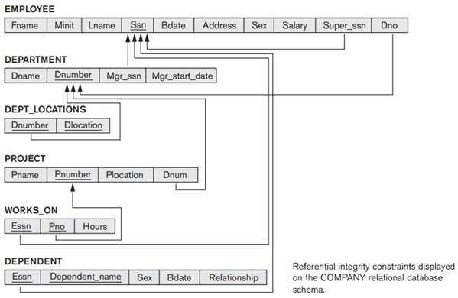
CREATE DATABASE FIRST;
USE FIRST;
CREATE TABLE EMPLOYEE(Fname VARCHAR(20),
Minit CHAR(3),
Lname VARCHAR(20),
Ssn INT NOT NULL,
Bdate DATE,
Address VARCHAR(50),
Sex CHAR(3),
Salary DECIMAL(7,2),
Super_ssn INT,
Dno INT,
PRIMARY KEY(Ssn),
CONSTRAINT fk1 FOREIGN KEY(Super_ssn) REFERENCES EMPLOYEE(Ssn));

SET FOREIGN_KEY_CHECKS=0;

INSERT INTO EMPLOYEE VALUE('John','B','Smith',123456789,'1965-01-09','731 Fondren,Houston,TX','M',30000,333445555,5);
INSERT INTO EMPLOYEE VALUE('Franklin','T','Wong',333445555,'1955-12-08','638 Voss,Houston,TX','M',40000,888665555,5);
INSERT INTO EMPLOYEE VALUE('Alicia','J','Zelaya',999887777,'1968-01-19','3321 Castle,Spring,TX','F',25000,987654321,4);
INSERT INTO EMPLOYEE VALUE('Jennifer','S','Wallace',987654321,'1941-08-20','291 Berry,Bellaire,TX','F',43000,888665555,4);
INSERT INTO EMPLOYEE VALUE('Ramesh','K','Narayan',666884444,'1962-09-15','975 Fire Oak,Humble,TX','M',38000,333445555,5);
INSERT INTO EMPLOYEE VALUE('Joyce','A','English',453453453,'1972-07-31','5631 Rice,Houston,TX','F',25000,333445555,5);
INSERT INTO EMPLOYEE VALUE('Ahmad','V','Jabbar',987987987,'1969-03-29','980 Dallas,Houston,TX','M',25000,987654321,4);
INSERT INTO EMPLOYEE VALUE('James','E','Borg',888665555,'1937-11-10','450 Stone.Houston,TX','M',55000,NULL,1);
SELECT * FROM EMPLOYEE;
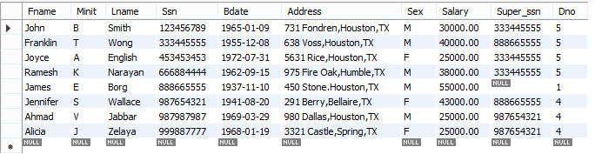
CREATE TABLE DEPARTMENT(Dname VARCHAR(30),
Dnumber INT NOT NULL,
Mgr_ssn INTEGER,
Mgr_start_date DATE,
PRIMARY KEY(Dnumber));
INSERT INTO DEPARTMENT VALUE('Research',5,333445555,'1988-05-22');
INSERT INTO DEPARTMENT VALUE('Administration',4,987654321,'1995-01-01');
INSERT INTO DEPARTMENT VALUE('Headquarters',1,888665555,'1981-06-19');
SELECT * FROM DEPARTMENT;
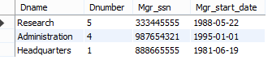

CREATE TABLE DEPT_LOCATIONS(Dnumber INT NOT NULL,
Dlocation CHAR(20) NOT NULL,
PRIMARY KEY(Dnumber,Dlocation),
CONSTRAINT dept_loc_fk1 FOREIGN KEY(Dnumber) REFERENCES DEPARTMENT(Dnumber));
INSERT INTO DEPT_LOCATIONS VALUE(1,'Houston');
INSERT INTO DEPT_LOCATIONS VALUE(4,'Stafford');
INSERT INTO DEPT_LOCATIONS VALUE(5,'Bellaire');
INSERT INTO DEPT_LOCATIONS VALUE(5,'Sugarland');
INSERT INTO DEPT_LOCATIONS VALUE(5,'Houston');
SELECT * FROM DEPT_LOCATIONS;
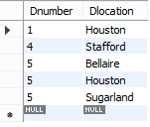
CREATE TABLE PROJECT(Pname VARCHAR(20),
Pnumber INT NOT NULL,
Plocation CHAR(20),
Dnum INT,
PRIMARY KEY(Pnumber),
CONSTRAINT project_fk1 FOREIGN KEY(Dnum) REFERENCES DEPARTMENT(Dnumber));
INSERT INTO PROJECT VALUE('ProductX',1,'Bellaire',5);
INSERT INTO PROJECT VALUE('ProductY',2,'Sugarland',5);
INSERT INTO PROJECT VALUE('ProductZ',3,'Houston',5);
INSERT INTO PROJECT VALUE('Computerization',10,'Stafford',4);
INSERT INTO PROJECT VALUE('Reorganization',20,'Houston',1);
INSERT INTO PROJECT VALUE('Newbenefits',30,'Stafford',4);
SELECT * FROM PROJECT;
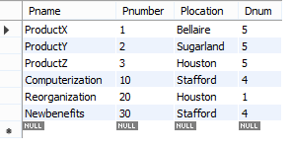
CREATE TABLE WORKS_ON(Essn INT NOT NULL,
Pno INT NOT NULL,
Hours TIME,
PRIMARY KEY(Essn,Pno),
CONSTRAINT works_onfk1 FOREIGN KEY(Essn) REFERENCES EMPLOYEE(Ssn),CONSTRAINT works_onfk2 FOREIGN KEY(Pno) REFERENCES PROJECT(Pnumber));
INSERT INTO WORKS_ON VALUE(123456789,1,'32:05:00'),
(123456789,2,'07:05:00'),
(666884444,3,'40:00:00'),
(453453453,1,'20:00:00'),
(453453453,2,'20:00:00'),
(333445555,2,'10:00:00'),
(333445555,3,'10:00:00'),
(333445555,10,'10:00:00'),
(333445555,20,'10:00:00'),
(999887777,30,'30:00:00'),
(999887777,10,'10:00:00'),
(987987987,10,'35:00:00'),
(987987987,30,'05:00:00'),
(987654321,30,'20:00:00'),
(987654321,20,'15:00:00'),
(888665555,20,NULL);

SELECT * FROM WORKS_ON;
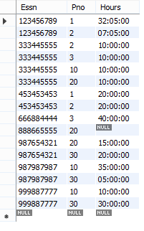
CREATE TABLE DEPENDENT(Essn INT NOT NULL,
Dependent_name VARCHAR(20),
Sex VARCHAR(1),
Bdate DATE,
Relationship VARCHAR(10),
PRIMARY KEY(Essn,Dependent_name),
CONSTRAINT dependentfk1 FOREIGN KEY(Essn) REFERENCES EMPLOYEE(Ssn));
INSERT INTO DEPENDENT VALUE
(333445555,'Alice','F','1986-04-05','Daughter'),
(333445555,'Theodore','M','1983-10-25','Son'),
(333445555,'Joy','F','1958-05-03','Spouse'),
(987654321,'Abner','M','1942-02-28','Spouce'),
(123456789,'Michael','M','1988-01-04','Son'),
(123456789,'Alice','F','1988-12-30','Daughter'),
(123456789,'Elizabeth','F','1967-05-05','Spouse');
SELECT * FROM DEPENDENT;

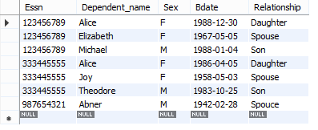
2. Retrieve the birth date and address of the employee whose name is “John B Smith”.
SELECT Bdate,Address
FROM EMPLOYEE
WHERE Fname='John' AND Minit='B' AND Lname='Smith';

3. Retrieve the name and address of all employees who work for the ‘Research’ department.
SELECT Fname,Minit,Lname,Address
FROM EMPLOYEE,DEPARTMENT
WHERE Dname='Research' AND Dnumber=Dno;
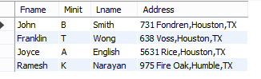

ALTER TABLE DEPARTMENT ADD PRIMARY KEY(Dnumber);

4. For every project located in ‘Stafford’, list the project number, the controlling department number, and the department manager’s last name, address, and birth date.
SELECT Pnumber ,Dnum,Lname,Address, Bdate
FROM EMPLOYEE, DEPARTMENT,PROJECT
WHERE Dnum=Dnumber AND Mgr_ssn=Ssn AND Plocation='Stafford';
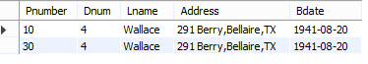
5. For each employee, retrieve the employee’s first and last name and the first and last name of his or her immediate supervisor.
SELECT E.Fname, E.Lname, S.Fname, S.Lname
FROM EMPLOYEE AS E, EMPLOYEE AS S
WHERE E.Super_ssn=S.ssn;
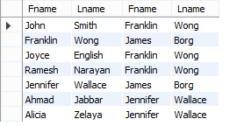
Unspecified WHERE clause and use of Asterisk
6. Select all EMPLOYEE Ssns in the database.
SELECT Ssn
FROM EMPLOYEE;
- A missing WHERE clause indicates no condition on tuple selection; hence all tuples of the relation specified in the FROM clause are selected for the query result.
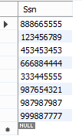
7. Select all combinations of EMPLOYEE Ssn and DEPARTMENT Dname in the database.
SELECT Ssn,Dname
FROM EMPLOYEE,DEPARTMENT;
- If more than one relation is specified in the FROM clause and there is no WHERE clause, then the CROSS PRODUCT - all possible tuple combinations- of these relations is selected.
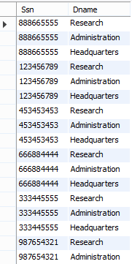
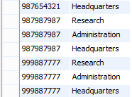

8. Retrieve all the attribute values of an EMPLOYEE who works in DEPARTMENT number 5.
SELECT *
FROM EMPLOYEE
WHERE Dno=5;
- To retrieve all the attribute values of the selected tuples, use asterisk(*), which stands for all the attributes.
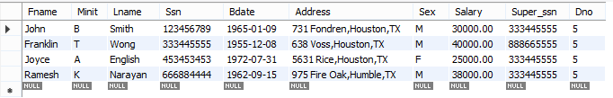
9. Retrieve all the attributes of an EMPLOYEE and the attributes of the DEPARTMENT in which he/she works for every employee of the ‘Research’ department.
SELECT *
FROM EMPLOYEE, DEPARTMENT
WHERE Dname='Research' AND Dnumber= Dno;
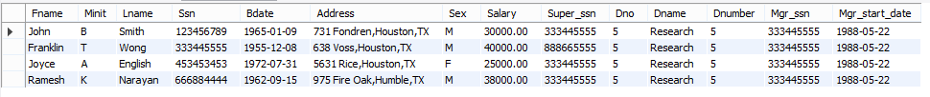
10. Write a query that specifies the CROSS PRODUCT of the EMPLOYEE and DEPARTMENT relations.
SELECT *
FROM EMPLOYEE, DEPARTMENT;
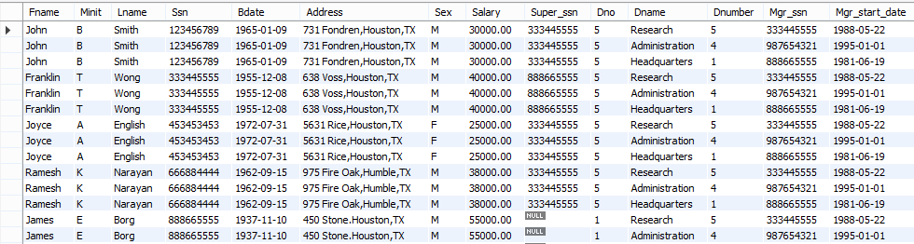
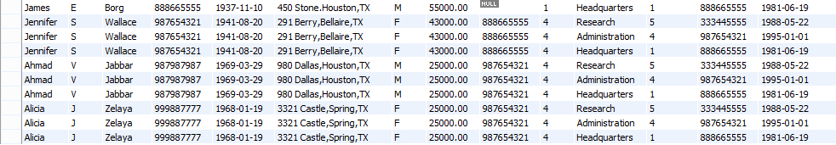
11. Retrieve the salary of every employee.(duplicates allowed)
SELECT ALL Salary
FROM EMPLOYEE;
OR
SELECT Salary
FROM EMPLOYEE;
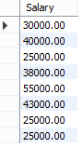
12. Retrieve all distinct salary values.
SELECT DISTINCT Salary
FROM EMPLOYEE;
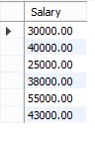
13. Make a list of all project numbers for projects that involve an employee whose last name is ‘Smith’ , either as a worker or as a manager of the department that controls the project.
(SELECT DISTINCT Pnumber
FROM PROJECT,DEPARTMENT,EMPLOYEE
WHERE Dnum=Dnumber AND Mgr_ssn=Ssn AND Lname='Smith')
UNION
(SELECT Pnumber
FROM PROJECT,WORKS_ON,EMPLOYEE
WHERE Pnumber=Pno AND Essn=Ssn AND Lname='Smith');
- The first SELECT query retrieves the projects that involve ‘Smith’ as manager of the department that controls the project and the second retrieves the projects that involve ‘Smith’ as a worker on the project.
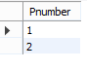
- UNION ALL allows duplicate values.
Substring pattern matching and Arithmetic operators
14. Retrieve all employees whose address is in Houston,Texas.
SELECT Fname,Minit,Lname
FROM EMPLOYEE
WHERE Address LIKE '%Houston,TX%';
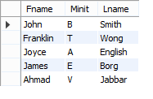
Partial strings are specified using two reserved characters:
- % replaces an arbitrary number of zero or more characters
- _(underscore) replaces a single character
15. Find all employees who were born during the 1950s.
SELECT Fname,Minit,Lname
FROM EMPLOYEE
WHERE Bdate LIKE '__5_______';
- 9 underscores is there
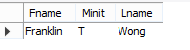
16. Show the resulting salaries if every employee working on the ‘ProductX’ project is given a 10 percent raise.
SELECT E.Fname, E.Lname, 1.1*E.Salary AS Increased_sal
FROM PROJECT AS P,WORKS_ON AS W,EMPLOYEE AS E

WHERE P.Pname='ProductX' AND P.Pnumber=W.Pno AND W.Essn=E.Ssn;
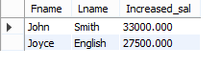
17.Retrieve all employees in department 5 whose salary is between $30,000 and $40,000.
SELECT *
FROM EMPLOYEE
WHERE (Salary BETWEEN 30000 AND 40000) AND Dno=5;
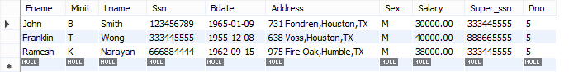
Comparisons involving NULL
18. Retrieve the names of all employees who do not have supervisors.
- SQL allows queries that check whether an attribute value is NULL. Rather than using = or < > to compare an attribute value to NULL, SQL uses the comparison operators IS or IS NOT.
SELECT Fname, Lname
FROM EMPLOYEE
WHERE Super_ssn IS NULL;
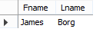
ORDER BY statement
19.Retrieve a list of employees and the projects they are working on, ordered by department and within each department, ordered alphabetically by last name ,then first name.
SELECT D.Dname, E.Lname, E.Fname, P.Pname
FROM DEPARTMENT D, EMPLOYEE E, WORKS_ON W,PROJECT P
WHERE D.Dnumber=E.Dno AND E.Ssn=W.Essn AND W.Pno=P.Pnumber
ORDER BY D.Dname, E.Lname,E.Fname;
RESULT
Successfully used DML commands for manipulating data.

EXPERIMENT 6
IMPLEMENTATION OF NESTED QUERIES AND JOIN QUERIES
AIM
Practice implementation of NESTED QUERIES and JOIN QUERIES
PROCEDURE
Refer the above table used in experiment 5.
1.Retrieve the name and address of all employees who work for the ‘Research’ department using nested queries.
USE FIRST;
SELECT Fname,Lname,Address
FROM EMPLOYEE
WHERE Dno IN(SELECT Dnumber
FROM DEPARTMENT
WHERE Dname='Research');
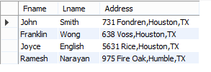
This is a non-correlated subquery (or independent/nested subquery) because the inner query (SELECT Dnumber FROM DEPARTMENT WHERE Dname='Research') can run once, independently, to find the 'Research' department's ID, and its result (a single number) is then used by the outer query to filter employees, making it efficient.
Since the inner query doesn't need any information from the EMPLOYEE table to execute, it's non-correlated and runs just once.
2. Return the names of employees whose salary is greater than the salary of all the employees from department number 5.
SELECT Fname,Lname
FROM EMPLOYEE
WHERE Salary> ALL (SELECT SALARY
FROM EMPLOYEE
WHERE Dno=5);
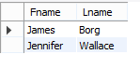
This is a non-correlated subquery, also known as a simple or independent subquery, because the inner query (SELECT SALARY FROM EMPLOYEE WHERE Dno=5) executes once to get all salaries for Department 5, and its result is then used by the outer query to compare against every employee's salary, without the inner query needing data from the outer query for each row.
The keyword ALL can be combined with each of > ,>= ,< ,<= and < > these operators.
3.Select the Essn of all employees who work in the same (project, hours) combination on some project that employee ‘John Smith’ (whose Ssn=’123456789’) works on.
SELECT DISTINCT Essn
FROM WORKS_ON
WHERE (Pno,Hours) IN (SELECT Pno, Hours
FROM WORKS_ON
WHERE Essn='123456789');
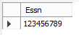
- This is a Non-correlated subquery:
  - The inner query (SELECT Pno, Hours FROM WORKS_ON WHERE Essn = '123456789') is independent of the outer query.
  - It can be executed once and its result set is then used by the outer query for comparison.
  - No column from the outer query is referenced inside the inner query.
4. Retrieve the name of each employee who has a dependent with the same first name and is the same sex as the employee.
SELECT E.Fname,E.Lname
FROM EMPLOYEE AS E
WHERE E.Ssn IN (SELECT Essn
FROM DEPENDENT AS D
WHERE E.Fname=D.Dependent_name AND E.Sex=D.Sex);
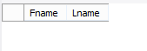
The subquery in theabove SQL statement is correlated because it references columns from the outer query.
5. Make a list of all project numbers for projects that involve an employee whose last name is ‘Smith’ , either as a worker or as a manager of the department that controls the project.
SELECT DISTINCT Pnumber
FROM PROJECT
WHERE Pnumber IN
(SELECT Pnumber
FROM PROJECT,DEPARTMENT,EMPLOYEE
WHERE Dnum=Dnumber AND Mgr_ssn=Ssn AND Lname='Smith')
OR
Pnumber IN
(SELECT Pno
FROM WORKS_ON,EMPLOYEE
WHERE Essn=Ssn AND Lname='Smith');
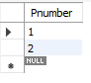
- We use the OR logical connective to retrieve a PROJECT tuple if the Pnumber value of that tuple is in the result of either nested query.
EXISTS and UNIQUE functions in SQL
EXISTS function in SQL is used to check whether the result of a correlated nested query is empty(contains no tuples ) or not.
6.Retrieve the name of each employee who has a dependent with the same sex as the employee.
SELECT E.Fname, E.Lname
FROM EMPLOYEE AS E
WHERE EXISTS
(SELECT *
FROM DEPENDENT AS D
WHERE E.Ssn=D.Essn AND E.Sex=D.Sex);
- The outer query retrieves the first name and last name of employees (E.Fname, E.Lname) and WHERE EXISTS (...) checks if at least one row exists in the DEPENDENT table that matches the given condition.
- This is a correlated subquery because the inner query uses a column from the outer query (E.Ssn, E.Sex).
- EXISTS is efficient for checking existence, not counting.
How EXISTS works
- EXISTS returns TRUE if the inner query returns at least one row.
- If TRUE, the employee is included in the result set.
- If FALSE, the employee is excluded.
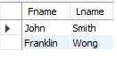

7. .Retrieve the name of each employee who has a dependent with the same first name and is the same sex as the employee.
SELECT E.Fname, E.Lname
FROM EMPLOYEE AS E
WHERE EXISTS
(SELECT *
FROM DEPENDENT AS D
WHERE E.Ssn=D.Essn AND E.Sex=D.Sex AND E.Fname= D.Dependent_name);

8. Retrieve the names of employees who have no dependents.
SELECT Fname,Lname
FROM EMPLOYEE
WHERE NOT EXISTS(SELECT *
FROM DEPENDENT
WHERE Ssn=Essn);
Here John Smith, Franklin Wong and Jennifer Wallace have Ssn=Essn. ie they have dependents. But here we use NOT EXISTS. So we retrieve names of all other employees.
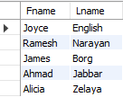

Explicit sets in SQL
It is also possible to use an explicit set of values in the WHERE clause, rather than a nested query. Such a set is enclosed in parentheses in SQL.
9. Retrieve the social security numbers of all employees who work on project numbers 1,2 or 3.
SELECT DISTINCT Essn
FROM WORKS_ON
WHERE Pno IN (1,2,3);
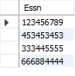
Joined tables in SQL
10. Retrieve the details of every employee who works on the research department using JOIN.
SELECT *
FROM (EMPLOYEE JOIN DEPARTMENT ON Dno=Dnumber)
WHERE Dname='Research';
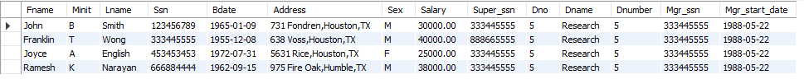
A JOIN clause is used to combine rows from two or more tables, based on a related column between them.
JOIN is used in the from clause of a query.
Different Types of SQL JOINs
Here are the different types of the JOINs in SQL:
- (INNER) JOIN: Returns records that have matching values in both tables
- LEFT (OUTER) JOIN: Returns all records from the left table, and the matched records from the right table
- RIGHT (OUTER) JOIN: Returns all records from the right table, and the matched records from the left table
- FULL (OUTER) JOIN: Returns all records when there is a match in either left or right table
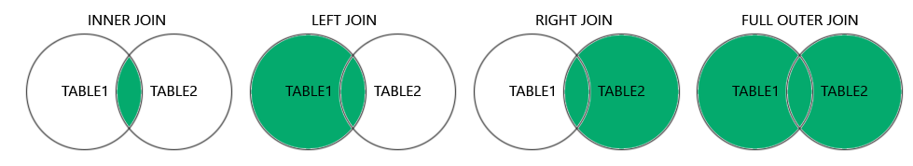
11. For every project located in 'Stafford', list the project number, the controlling department number, and the department manager’s last name, address, and birth date.
SELECT Pnumber, Dnum,Lname, Address, Bdate
FROM ((PROJECT JOIN DEPARTMENT ON Dnum=Dnumber) JOIN EMPLOYEE ON Mgr_ssn=Ssn)
WHERE Plocation='Stafford';
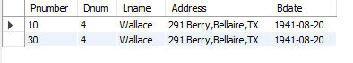
- It is also possible to nest join specifications ie one of the tables in a join may itself be a joined table. This allows the specification of the join of three or more tables as a single joined table, which is called a multiway join.

RESULT
- Successfully implemented nested queries and join queries.

EXPERIMENT 7
IMPLEMENTATION OF AGGREGATE FUNCTIONS, GROUP BY & HAVING CLAUSE
AIM
Practice implementation of various Aggregate functions, GROUP BY & HAVING Clause in SQL.
PROCEDURE
Refer the above table used in experiment 5.
1.Write the query to find the sum of the salaries of all employees, the maximum salary, the minimum salary and the average salary.
SELECT SUM(Salary), MAX(Salary),MIN(Salary),AVG(Salary)
FROM EMPLOYEE;
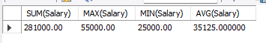
2. Find the sum of the salaries of all employees of the ‘Research’ department, as well as the maximum salary, the minimum salary and the average salary in this department.
SELECT SUM(Salary), MAX(Salary),MIN(Salary),AVG(Salary)
FROM (EMPLOYEE JOIN DEPARTMENT ON Dno=Dnumber)
WHERE Dname='Research';
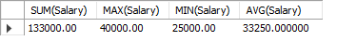
3. Retrieve the total number of employees in the company.
SELECT COUNT(*)
FROM EMPLOYEE;
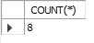
- COUNT(*)- counts all the number of rows of the table including NULL.
- COUNT(COLUMN_NAME)- count number of non-null values in column.
Eg:
SELECT COUNT(Super_ssn)
FROM EMPLOYEE;
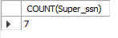
- COUNT(DISTINCT COLUMN_NAME)- count number of distinct values in a column.
Eg:
SELECT COUNT(DISTINCT Super_ssn)
FROM EMPLOYEE;
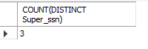
4. Find the number of employees in the ‘Research’ department.
SELECT COUNT(*)
FROM EMPLOYEE,DEPARTMENT
WHERE Dno=Dnumber AND Dname='Research';
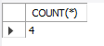
5. Count the number of distinct salary values of the employees.
SELECT COUNT(DISTINCT Salary)
FROM EMPLOYEE;
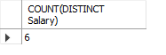
6. Retrieve the names of all employees who have two or more dependents.
SELECT Fname, Lname
FROM EMPLOYEE
WHERE (SELECT COUNT(*)
FROM DEPENDENT
WHERE Ssn=Essn)>=2;
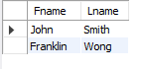
The Group by and Having clause
- The GROUP BY clause in SQL is used to group rows that have the same values in specified columns into summary rows. The HAVING clause is used to filter groups based on a condition involving aggregate functions.
Important Considerations
- GROUP BY: This clause is used to arrange identical data into groups. It is often used with aggregate functions like SUM, AVG, COUNT, etc.
- HAVING: This clause is used to filter groups created by the GROUP BY clause. It applies conditions on aggregated data and is typically used with aggregate functions.
- WHERE filter individual rows before grouping, GROUP BY arrange identical data into groups, HAVING filters group created by group by.
7. For each department, retrieve the department number, the number of employees in the department, and their average salary.
SELECT Dno, COUNT(*), AVG(Salary)
FROM EMPLOYEE
GROUP BY Dno;
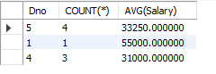
- If the EMPLOYEE table had some tuples that had NULL for the grouping attribute, there would be a separate group for those tuples in the result.
Eg: Select the number of employees working under each supervisor.
SELECT Super_ssn, COUNT(*)
FROM EMPLOYEE
GROUP BY Super_ssn;
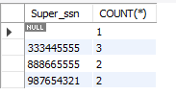
- Eg: Select the name of employees working under each supervisor.
SELECT Super_ssn, COUNT(*), Fname, Lname
FROM EMPLOYEE
GROUP BY Super_ssn,Fname, Lname;
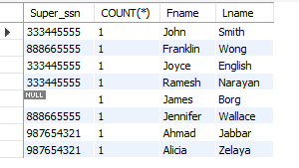
8. For each project, retrieve the project number, the project name, and the number of employees who work on that project.
SELECT Pnumber, Pname, COUNT(*)
FROM PROJECT, WORKS_ON
WHERE Pnumber=Pno
GROUP BY Pnumber,Pname;
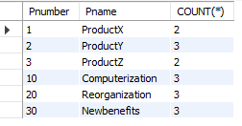
In standard SQL, the rule is:
- Every column (attribute) in the SELECT clause other than aggregate function must appear in the GROUP BY clause.

Why?
When you use GROUP BY, SQL needs to know how to group rows for every non-aggregated column in the SELECT list.
If a column is not aggregated and not in GROUP BY, SQL cannot determine which value to display for that column in each group.

Having clause
9. For each project on which more than two employees work, retrieve the project number, the project name, and the number of employees who work on the project.
SELECT Pnumber,Pname,COUNT(*)
FROM PROJECT, WORKS_ON
WHERE Pnumber=Pno
GROUP BY Pnumber,Pname
HAVING COUNT(*)>2;
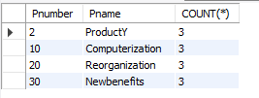
10. For each project, retrieve the project number, the project name, and the number of employees from department 5 who work on the project.
SELECT Pnumber,Pname,COUNT(*)
FROM PROJECT, WORKS_ON, EMPLOYEE
WHERE Pnumber=Pno AND Essn=Ssn AND Dno=5
GROUP BY Pnumber,Pname;
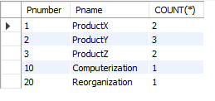
RESULT
Successfully implemented aggregate functions, group by & having clause.

Experiment 8
TCL AND DCL COMMANDS

AIM
Practice of SQL TCL commands like Rollback, Commit, Savepoint, Practice of SQL DCL com-mands for granting and revoking user privileges.
THEORY
Transaction Control Language (TCL)
• Used to manage and control database transactions.
• START TRANSACTION begins a transaction.
• SAVEPOINT creates a checkpoint within a transaction.
• ROLLBACK TO savepoint undoes changes made after a specific savepoint.
• ROLLBACK cancels all changes made in the transaction.
• COMMIT permanently saves changes to the database.
• TCL helps maintain data consistency and integrity.
Data Control Language (DCL)
• Used to control access and security in a database.
• CREATE USER creates a new database user.
• GRANT gives permissions to a user.
• REVOKE removes permissions from a user.
• DROP USER deletes a user from the database.
• DCL ensures secure access control in the database.
QUESTION
TCL commands
1. Create a database
2. Create a table EMPLOYEES(EmpID, Empname,Salary)
3. Start a transaction, insert the details of two employees, create first checkpoint
4. Insert the details of third employee, create second checkpoint
5. Insert the details of fourth employee, view the table details
6. Rollback to second checkpoint, view the table details
7. Rollback to first checkpoint, view the table details
8. Rollback entire transaction.
9. View table after full rollback

DCL commands
1. Create a new database user account
2. Grant him SELECT and INSERT privilege.
3. Grant him all privileges
4. Revoke INSERT privilege
5. Revoke all privileges
6. Remove the user.

QUERY
-- Create database
CREATE DATABASE IF NOT EXISTS Exp_7;
USE Exp_7;

-- Create Employees table
CREATE TABLE Employees (
EmpID INT PRIMARY KEY,
EmpName VARCHAR(50),
Salary INT
);

-- =========================================
-- TCL COMMANDS
-- =========================================
-- Start transaction (manual control begins)
START TRANSACTION;
-- Insert initial records
INSERT INTO Employees VALUES (1, 'John', 36000);
INSERT INTO Employees VALUES (2, 'Asha', 39000);
-- View table after first insert
SELECT * FROM Employees;
-- Create savepoint A (first checkpoint)
SAVEPOINT A;
-- Insert another record
INSERT INTO Employees VALUES (3, 'Rahul', 42000);
-- View table after second insert
SELECT * FROM Employees;
-- Create savepoint B (second checkpoint)
SAVEPOINT B;
-- Insert one more record
INSERT INTO Employees VALUES (4, 'Meena', 45000);
-- View table after third insert
SELECT * FROM Employees;
-- Rollback to savepoint B
ROLLBACK TO B;
-- (Undo changes made after savepoint B, not entire transaction)
SELECT * FROM Employees;
ROLLBACK TO A;
-- View table after rollback to savepoint
SELECT * FROM Employees;
-- Rollback entire transaction
-- (Undo all changes since START TRANSACTION)
ROLLBACK;
-- View table after full rollback
SELECT * FROM Employees;
-- =========================================
--- =========================================
-- DCL COMMANDS
-- =========================================

-- Create a new user
CREATE USER 'test'@'localhost' IDENTIFIED BY 'pass123';
-- Grant SELECT and INSERT privileges on Employees table
GRANT SELECT, INSERT
ON Exp_7.Employees
TO 'test'@'localhost';

-- Apply privilege changes
FLUSH PRIVILEGES;
-- Check granted privileges
SHOW GRANTS FOR 'test'@'localhost';
-- Grant all privileges on Employees table
GRANT ALL PRIVILEGES
ON Exp_7.Employees
TO 'test'@'localhost';
-- Apply changes
FLUSH PRIVILEGES;
-- Revoke INSERT privilege from the user
REVOKE INSERT
ON Exp_7.Employees
FROM 'test'@'localhost';
-- Apply changes
FLUSH PRIVILEGES;
-- Check privileges after revoke
SHOW GRANTS FOR 'test'@'localhost';
-- Remove all privileges and delete the user
REVOKE ALL PRIVILEGES, GRANT OPTION
FROM 'test'@'localhost';
DROP USER 'test'@'localhost';

OUTPUT
TCL
mysql> START TRANSACTION;
Query OK, 0 rows affected (0.00 sec)

inserted 2 values
mysql> SELECT * FROM Employees;
+-------+---------+--------+
| EmpID | EmpName | Salary |
+-------+---------+--------+
| 1 | John | 36000 |
| 2 | Asha | 39000 |
+-------+---------+--------+
2 rows in set (0.00 sec)

mysql> -- Create savepoint A (first checkpoint)
mysql> SAVEPOINT A;
Query OK, 0 rows affected (0.00 sec)
mysql> INSERT INTO Employees VALUES (3, 'Rahul', 42000);
Query OK, 1 row affected (0.00 sec)

mysql> SELECT * FROM Employees;
+-------+---------+--------+
| EmpID | EmpName | Salary |
+-------+---------+--------+
| 1 | John | 36000 |
| 2 | Asha | 39000 |
| 3 | Rahul | 42000 |
+-------+---------+--------+
3 rows in set (0.00 sec)

mysql> SAVEPOINT B;
Query OK, 0 rows affected (0.00 sec)

mysql> INSERT INTO Employees VALUES (4, 'Meena', 45000);
Query OK, 1 row affected (0.00 sec)

mysql> SELECT * FROM Employees;
+-------+---------+--------+
| EmpID | EmpName | Salary |
+-------+---------+--------+
| 1 | John | 36000 |
| 2 | Asha | 39000 |
| 3 | Rahul | 42000 |
| 4 | Meena | 45000 |
+-------+---------+--------+
4 rows in set (0.00 sec)

mysql> ROLLBACK TO A;
Query OK, 0 rows affected (0.00 sec)

mysql> SELECT * FROM Employees;
+-------+---------+--------+
| EmpID | EmpName | Salary |
+-------+---------+--------+
| 1 | John | 36000 |
| 2 | Asha | 39000 |
+-------+---------+--------+
2 rows in set (0.00 sec)

mysql> ROLLBACK;
Query OK, 0 rows affected (0.00 sec)
mysql> SELECT * FROM Employees;
Empty set (0.00 sec)

DCL
mysql> CREATE USER 'test'@'localhost' IDENTIFIED BY 'pass123';
Query OK, 0 rows affected (0.01 sec)
mysql> -- Grant SELECT and INSERT privileges on Employees table
mysql> GRANT SELECT, INSERT
-> ON Exp_TCL_DCL.Employees
-> TO 'test'@'localhost';
Query OK, 0 rows affected (0.00 sec)

mysql> FLUSH PRIVILEGES;
Query OK, 0 rows affected (0.00 sec)

mysql> SHOW GRANTS FOR 'test'@'localhost';
+-------------------------------------------------------------------------+
| Grants for test@localhost |
+-------------------------------------------------------------------------+
| GRANT USAGE ON *.* TO `test`@`localhost` |
| GRANT SELECT, INSERT ON `Exp_TCL_DCL`.`Employees` TO `test`@`localhost` |
+-------------------------------------------------------------------------+
2 rows in set (0.00 sec)

mysql> -- Grant all privileges on Employees table
mysql> GRANT ALL PRIVILEGES
-> ON Exp_TCL_DCL.Employees
-> TO 'test'@'localhost';
Query OK, 0 rows affected (0.00 sec)

mysql> REVOKE INSERT
-> ON Exp_TCL_DCL.Employees
-> FROM 'test'@'localhost';
Query OK, 0 rows affected (0.00 sec)

mysql> FLUSH PRIVILEGES;
Query OK, 0 rows affected (0.00 sec)

mysql> SHOW GRANTS FOR 'test'@'localhost';
+----------------------------------------------------------------------------------------------------------------------------------------------------------+
| Grants for test@localhost |
+----------------------------------------------------------------------------------------------------------------------------------------------------------+
| GRANT USAGE ON *.* TO `test`@`localhost` |
| GRANT SELECT, UPDATE, DELETE, CREATE, DROP, REFERENCES, INDEX, ALTER, CREATE VIEW, SHOW VIEW, TRIGGER ON `Exp_TCL_DCL`.`Employees` TO `test`@`localhost` |
+----------------------------------------------------------------------------------------------------------------------------------------------------------+
2 rows in set (0.00 sec)

mysql> REVOKE ALL PRIVILEGES, GRANT OPTION
-> FROM 'test'@'localhost';
Query OK, 0 rows affected (0.00 sec)

mysql> DROP USER 'test'@'localhost';
Query OK, 0 rows affected (0.00 sec)

RESULT
Successfully implemented TCL and DCL commands.

EXTRA READ
Let’s say I have the database DB1 and it contain Employees table.
1)
CREATE USER 'test'@'localhost' IDENTIFIED BY 'pass123';
This command is a MySQL statement used to create a new database user account.
Here’s what each part means:
• CREATE USER → Tells MySQL you want to make a new user.
• 'test'@'localhost' → Defines the username (test) and the host from which the user can connect (localhost means only from the same machine where MySQL is running).
• IDENTIFIED BY 'pass123' → Sets the password for the new user to pass123.
Example in plain words:
“Create a MySQL user named test who can log in only from the local computer, and whose password is pass123.”

2)
GRANT SELECT, INSERT
ON DB1.Employees
TO 'test'@'localhost';
Grant SELECT and INSERT privileges on Employees table
FLUSH PRIVILEGES;
The FLUSH PRIVILEGES statement in MySQL is used to reload the grant tables, ensuring that any changes made to user permissions are immediately applied without requiring a server restart.
SHOW GRANTS FOR 'test'@'localhost';
OUTPUT
GRANT USAGE ON *.* TO `test`@`localhost`
GRANT SELECT, INSERT ON `db1`.`employees` TO `test`@`localhost`

GRANT USAGE ON *.* TO `test`@`localhost '
The command GRANT USAGE ON . TO `test`@`localhost` is used to grant the usage privilege to the user `test`@`localhost '. This privilege allows the user to log in to the MySQL server but does not grant any specific privileges to perform operations on database objects.
3.
GRANT ALL PRIVILEGES
ON DB1.Employees
TO 'test'@'localhost';
Granting all privileges (SELECT, INSERT, DELETE, INDEX, CREATE, ALTER,DROP, ALL, UPDATE,GRANT)on the Employees table in the DB1 database to the MySQL us-er 'test'@'localhost'.
FLUSH PRIVILEGES;
SHOW GRANTS FOR 'test'@'localhost';
OUTPUT
GRANT USAGE ON *.* TO `test`@`localhost`
GRANT ALL PRIVILEGES ON `db1`.`employees` TO `test`@`localhost`

4.
REVOKE INSERT
ON DB1.Employees
FROM 'test'@'localhost';
It will remove the INSERT privilege for the user test (connecting from localhost) on the Employees table in the DB1 database.
FLUSH PRIVILEGES;
SHOW GRANTS FOR 'test'@'localhost';
OUTPUT
GRANT USAGE ON *.* TO `test`@`localhost`
GRANT SELECT, UPDATE, DELETE, CREATE, DROP, REFERENCES, INDEX, ALTER, CREATE VIEW, SHOW VIEW, TRIGGER ON `db1`.`employees` TO `test`@`localhost`

5.
REVOKE ALL PRIVILEGES, GRANT OPTION
FROM 'test'@'localhost';
Meaning:
• REVOKE ALL PRIVILEGES: Removes all permissions the us-er 'test'@'localhost' currently has (e.g., SELECT, INSERT, UPDATE, etc.) across all databases.
• GRANT OPTION: Removes the ability for that user to grant privileges to others.
• FROM 'test'@'localhost': Targets the specific MySQL account with username test connecting from localhost.
FLUSH PRIVILEGES;
SHOW GRANTS FOR 'test'@'localhost';
OUTPUT
GRANT USAGE ON *.* TO `test`@`localhost`

6.
DROP USER 'test'@'localhost';
• Unlike REVOKE, which removes privileges but keeps the user, DROP US-ER removes the user entirely.

Experiment 9
VIEW AND ASSERTION

AIM
Practice of SQL commands for creation of views and assertions.
VIEW
-- A VIEW is a virtual table in DBMS that shows data from one or more base tables.
-- It does not store data physically but provides a customized representation of data.
-- Views help simplify complex queries, provide data security, and allow users to access only relevant information

Query
-- 1. Create Database and Use It
CREATE DATABASE college;
USE college;
-- 2. Create Student Table
CREATE TABLE student (
roll_no INT PRIMARY KEY, -- Unique Roll Number
name VARCHAR(50), -- Student Name
age INT, -- Student Age
marks INT -- Student Marks
);
-- 3. Insert Sample Data into Student Table
INSERT INTO student VALUES
(1, 'Amit', 19, 75),
(2, 'Riya', 18, 35),
(3, 'Karan', 20, 60);
-- 4. Display All Student Data
SELECT * FROM student;
-- 5. Create a View to Show Passed Students (marks >= 40)
CREATE VIEW passed_students AS
SELECT roll_no, name, marks
FROM student
WHERE marks >= 40;
-- 6. Display Data from the View
SELECT * FROM passed_students;
--7. Specify SQL query on a view. Select name of the student from created view whose roll number is 1.
SELECT name
FROM passed_students
WHERE roll_no=1;
8. Drop the view
DROP VIEW passed_students;

ASSERTION
THEORY:
-- An ASSERTION is a global integrity constraint that ensures a condition remains true across one or more tables. It is part of the SQL standard.
-- Most DBMS do not enforce assertions, so they are mainly used for conceptual understanding.
Conceptual Assertion Example:
CREATE ASSERTION valid_marks
CHECK (NOT EXISTS (
SELECT *
FROM student
WHERE marks < 0 OR marks > 100
));

Conceptual use:
-- If assertions were supported, the following invalid insertion would be rejected:
-- INSERT INTO student VALUES (4, 'Neha', 19, 150);

PRACTICAL ALTERNATIVE TO ASSERTION
-- Since assertions are not enforced in most DBMS, table-level constraints such as CHECK can be used to enforce rules like valid age or marks range.
Query:
--Create a New Table with CHECK Constraints
CREATE TABLE student2 (
roll_no INT PRIMARY KEY, -- Unique Roll Number
name VARCHAR(50), -- Student Name
age INT CHECK (age >= 18), -- Age must be >= 18
marks INT CHECK (marks BETWEEN 0 AND 100) -- Marks must be between 0 and 100
);

--Insert Valid Data into student2
INSERT INTO student2 VALUES
(1, 'Amit', 19, 75),
(2, 'Riya', 18, 35),
(3, 'Karan', 20, 60);

-- Attempt to Insert Invalid Data (Marks > 100) – This will fail
INSERT INTO student2 VALUES (4, 'Neha', 19, 150);

-- Display Table to Confirm Constraints are Enforced
SELECT * FROM student2;

OUTPUT
View
Table created, data inserted.
SELECT * FROM student;
+---------+-------+------+-------+
| roll_no | name | age | marks |
+---------+-------+------+-------+
| 1 | Amit | 19 | 75 |
| 2 | Riya | 18 | 35 |
| 3 | Karan | 20 | 60 |
+---------+-------+------+-------+
3 rows in set (0.00 sec)
CREATE VIEW passed_students AS
-> SELECT roll_no, name, marks
FROM student
WHERE marks >= 40;
Query OK, 0 rows affected (0.01 sec)
mysql> SELECT * FROM passed_students;
+---------+-------+-------+
| roll_no | name | marks |
+---------+-------+-------+
| 1 | Amit | 75 |
| 3 | Karan | 60 |
+---------+-------+-------+
2 rows in set (0.00 sec)
SELECT name
FROM passed_students
WHERE roll_no=1;
+------+
| name |
+------+
| Amit |
+------+

Assertion
Table created, data inserted
Attempt to insert invalid data
INSERT INTO student2 VALUES (4, 'Neha', 19, 150);
ERROR 3819 (HY000): Check constraint 'student2_chk_2' is violated.

mysql> SELECT * FROM student2;
+---------+-------+------+-------+
| roll_no | name | age | marks |
+---------+-------+------+-------+
| 1 | Amit | 19 | 75 |
| 2 | Riya | 18 | 35 |
| 3 | Karan | 20 | 60 |
+---------+-------+------+-------+
3 rows in set (0.00 sec)

RESULT
The sql queries executed successfully and obtained the result.

Experiment 10
PROCEDURE,TRIGGER AND FUNCTION

AIM
To practice creation of Procedures, Triggers and Functions.
Theory
Function
A function in MySQL is a stored program that accepts input values, performs a computation, and
produces a single output value.
It is mainly used when a calculated value is required repeatedly inside SQL queries.
A function always specifies a return data type and uses the RETURN statement to send back the
result.
Syntax
DELIMITER $$
CREATE FUNCTION function_name(parameter datatype)
RETURNS datatype
BEGIN
statements;
RETURN value;
END $$
DELIMITER ;
Procedure
A procedure is a stored program designed to execute a series of database operations.
It is invoked using the CALL statement and does not return a value using RETURN.
Procedures can accept input values, output values, or both.
Syntax
DELIMITER $$
CREATE PROCEDURE procedure_name(
IN parameter datatype,
OUT parameter datatype,
INOUT parameter datatype
)
BEGIN
statements;
END $$
DELIMITER ;
Trigger
A trigger is a stored program that executes automatically when a specified action occurs on a table.
It is associated with insert, update, or delete operations and can execute either before or after the
event.
Syntax
DELIMITER $$
CREATE TRIGGER trigger_name
BEFORE | AFTER INSERT | UPDATE | DELETE
ON table_name
FOR EACH ROW
BEGIN
statements;
END $$
DELIMITER ;
DELIMITER
DELIMITER is used to temporarily change the statement terminator so that MySQL can correctly process multiple statements inside stored programs.

Query
-- =====================================================
-- STEP 1: CREATE DATABASE -- =====================================================
CREATE DATABASE IF NOT EXISTS company_db;
-- Use the database
USE company_db;
-- =====================================================
-- STEP 2: CREATE EMPLOYEE TABLE -- =====================================================
CREATE TABLE Employee (
emp_id INT PRIMARY KEY,
emp_name VARCHAR(50),
salary DECIMAL(10,2)
);
-- =====================================================
-- STEP 3: INSERT SAMPLE DATA -- =====================================================
INSERT INTO Employee (emp_id, emp_name, salary) VALUES
(101, 'Anu', 25000),
(102, 'Rahul', 30000),
(103, 'Meera', 28000),
(104, 'Arjun', 35000);

-- View initial data
SELECT * FROM Employee;

-- =====================================================
-- STEP 4: FUNCTION – CALCULATE YEARLY SALARY -- =====================================================
-- This function returns yearly salary of an employee
DELIMITER $$
CREATE FUNCTION GetYearlySalary(empid INT)
RETURNS DECIMAL(10,2)
DETERMINISTIC
BEGIN
DECLARE yearly DECIMAL(10,2);
SELECT salary * 12
INTO yearly
FROM Employee
WHERE emp_id = empid;
RETURN yearly;
END $$
DELIMITER ;
-- Test function
SELECT emp_name, GetYearlySalary(emp_id) AS yearly_salary
FROM Employee;
-- =====================================================
-- STEP 5: PROCEDURE – INCREASE SALARY -- =====================================================
-- This procedure increases salary and shows updated details

DELIMITER $$
CREATE PROCEDURE increase_salary(
IN empid INT,
IN increment DECIMAL(10,2)
)
BEGIN
UPDATE Employee
SET salary = salary + increment
WHERE emp_id = empid;
SELECT emp_id, emp_name, salary
FROM Employee
WHERE emp_id = empid;
END $$
DELIMITER ;

-- Disable safe updates (needed in terminal)
SET sql_safe_updates = 0;

-- Call procedure
CALL increase_salary(102, 5000);
-- =====================================================
-- STEP 6: BEFORE UPDATE TRIGGER – PREVENT NEGATIVE SALARY
-- =====================================================

-- This trigger sets salary to 0 if updated salary is negative
DELIMITER $$
CREATE TRIGGER before_salary_update
BEFORE UPDATE ON Employee
FOR EACH ROW
BEGIN
IF NEW.salary < 0 THEN
SET NEW.salary = 0;
END IF;
END $$
DELIMITER ;

-- Test BEFORE UPDATE trigger
UPDATE Employee
SET salary = -1000
WHERE emp_id = 103;
-- Verify salary correction
SELECT * FROM Employee;
-- =====================================================
-- STEP 7: AFTER DELETE TRIGGER – STORE DELETED EMPLOYEES
-- =====================================================
-- Table to store deleted employee details
CREATE TABLE DeletedEmployees (
emp_id INT,
emp_name VARCHAR(50),
deleted_at TIMESTAMP DEFAULT CURRENT_TIMESTAMP
);

-- Trigger to insert deleted record into backup table
DELIMITER $$
CREATE TRIGGER after_employee_delete
AFTER DELETE ON Employee
FOR EACH ROW
BEGIN
INSERT INTO DeletedEmployees(emp_id, emp_name)
VALUES (OLD.emp_id, OLD.emp_name);
END $$
DELIMITER ;
-- Test AFTER DELETE trigger
DELETE FROM Employee WHERE emp_id = 103;
-- Verify deleted employee backup
SELECT * FROM DeletedEmployees;

Output
database created, Table created inserted values
SELECT * FROM Employee;
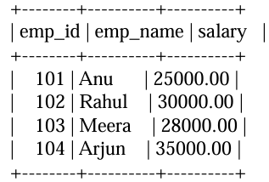
4 rows in set (0.00 sec)
--Function created
--test function

SELECT emp_name, GetYearlySalary(emp_id) AS yearly_salary FROM Employee;
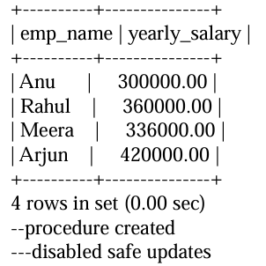
mysql> SET sql_safe_updates = 0;
Query OK, 0 rows affected (0.00 sec)

--call procedure
mysql> CALL increase_salary(102, 5000);
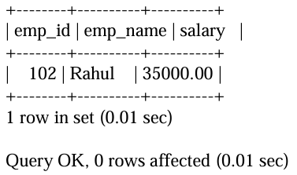

--Trigger 1 created—to prevent negative salary(This trigger sets salary to 0 if updated salary is
negative)
--Test BEFORE UPDATE trigger
mysql> UPDATE Employee SET salary = -1000 WHERE emp_id = 103;
Query OK, 1 row affected (0.00 sec)
Rows matched: 1 Changed: 1 Warnings: 0
mysql>
mysql> -- Verify salary correction
mysql> SELECT * FROM Employee;
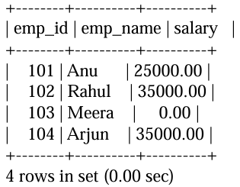
--Trigger 2 created--able to store deleted employee details(Trigger to insert deleted record into
backup table)
mysql> -- Test AFTER DELETE trigger
mysql> DELETE FROM Employee WHERE emp_id = 103;
Query OK, 1 row affected (0.00 sec)

mysql> -- Test AFTER DELETE trigger
mysql> DELETE FROM Employee WHERE emp_id = 103;
Query OK, 1 row affected (0.00 sec)

RESULT
The sql queries for the creation of Procedures, Triggers and Functions executed successfully and obtained the result.

Experiment 11
MySQL STORED PROCEDURE PROGRAMMING
AIM
Practice the use of variables, conditional structures and loops with MySQL stored procedures.
THEORETICAL BACKGROUND:
In MySQL stored procedures, parameters can be declared as IN, OUT, or INOUT, and each has a specific purpose in how data is passed between the caller and the procedure.
1. IN Parameters
Purpose: Pass values into the procedure.
Behavior: The procedure cannot modify the original variable in the caller; changes inside the procedure do not affect the caller’s variable.
Default: If you don’t specify a type, it’s treated as IN.
2. OUT Parameters
Purpose: Return values from the procedure to the caller.
Behavior: The procedure can set the value, and the caller can read it after execution.
The initial value passed in is ignored.
3. INOUT Parameters
Purpose: Pass a value into the procedure, possibly modify it, and return the new value.
Behavior: Acts like a reference — the procedure can read and modify the variable.
MySQL simple IF-THEN statement
- If the condition evaluates to TRUE, the statements between IF-THEN and END IF will execute.
- Otherwise, the control is passed to the next statement following the END IF. Second, specify the code that will execute if the condition evaluates to TRUE.
The MySQL LOOP statement could be used to run a block of code or set of statements, again and again, depending on the condition.
QUERIES:
1.
a) Write a stored procedure to accept values of a, b and c and display which one is greatest.
USE db;
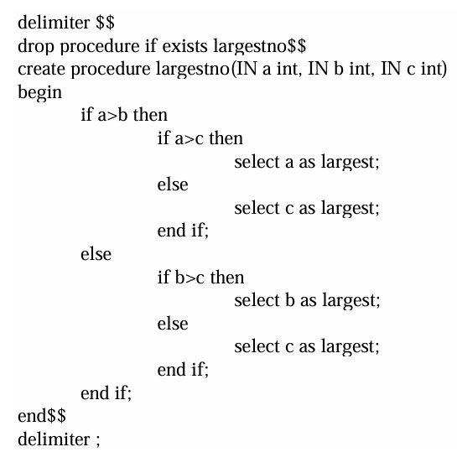
CALL largestno(10,20,30);
OUTPUT
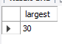
b) Write a stored procedure to accept values of a, b and c and display which one is greatest with the use of ‘in’ and ‘out’ parameters.
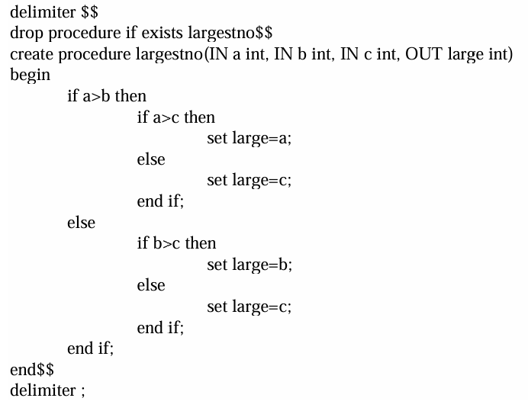
-- Declare a variable to hold the result
SET @largest = 0;

-- Call the procedure with three numbers
CALL largestno(12, 45, 33, @largest);

-- View the result
SELECT @largest AS LargestNumber;
OUTPUT
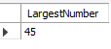
c) Write a stored procedure to accept values of a, b and c and display which one is greatest using
‘inout’ parameter.

DELIMITER $$

-- Drop the procedure if it already exists
DROP PROCEDURE IF EXISTS largestno $$

-- Create the procedure
CREATE PROCEDURE largestno(INOUT a INT, IN b INT, IN c INT)
BEGIN
IF a > b THEN
IF a > c THEN
-- a is already the largest
SET a = a;
ELSE
SET a = c;
END IF;
ELSE
IF b > c THEN
SET a = b;
ELSE
SET a = c;
END IF;
END IF;

-- Output the largest number
SELECT a AS largest;
END $$
DELIMITER ;

SET @x = 10;
CALL largestno(@x, 25, 15); -- Output: largest = 25
SELECT @x; -- @x now holds 25
OUTPUT
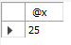
2. Pass a student mark for one subject as input to a procedure displaying the grade (A to F). (Do using CASE statement)
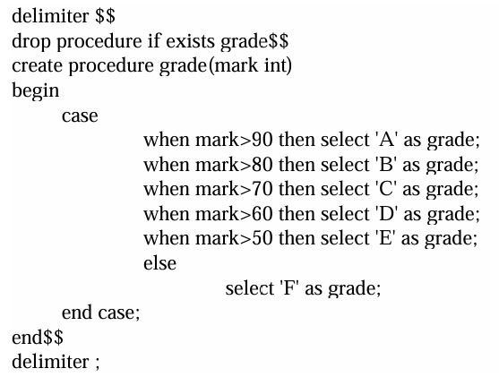
CALL GRADE(95);
OUTPUT
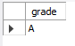
3. Write a stored procedure to find the sum of ‘n’ natural numbers. (Do using LOOP-END LOOP)
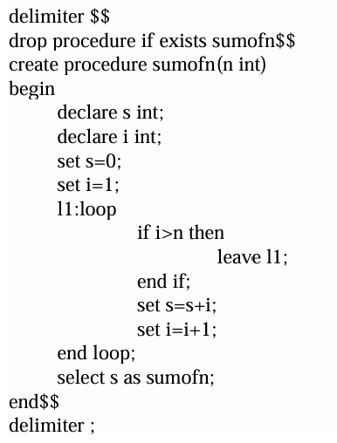
CALL SUMOFN(5);
OUTPUT
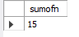
4. Write a stored procedure to find the sum of odd numbers up to ‘n’. (Do using REPEAT – UNTIL)
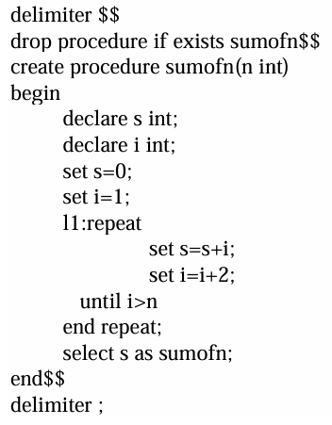
CALL SUMOFN(10);
OUTPUT
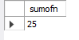
5. Write a stored procedure to find the sum of even numbers up to ‘n’. (Do using WHILE).
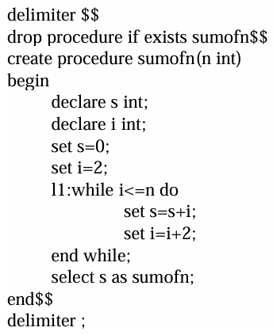
CALL SUMOFN(10);
OUTPUT
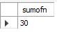
6. Write a stored procedure to find the number of digits in an input integer.
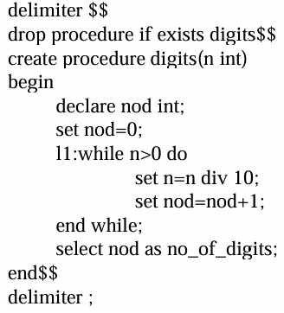
CALL DIGITS(2134);
OUTPUT
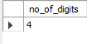
7. Accept two values ‘a’ and ‘b’ and swap them within a procedure using ‘inout’ parameter
delimiter $$
drop procedure if exists swap$$
create procedure swap(INOUT a int, INOUT b int)
begin
declare temp int;
set temp=a;
set a=b;
set b=temp;
end$$
delimiter ;
SET @a = 10,@b=20;
CALL swap(@a,@b);
SELECT @a as a,@b as b;
OUTPUT
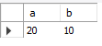
RESULT
Successfully practiced use of variables, conditional structures and loops with MySQL stored procedures

Experiment 12
FAMILARISATION OF SQL COMMANDS
AIM
To study and execute basic SQL commands such as CREATE, INSERT, ALTER, UPDATE, DELETE, and SELECT using MySQL.
THEORETICAL BACKGROUND:
Structured Query Language (SQL) is used to manage and manipulate data in relational databases. It provides commands to create database structures, insert records, retrieve data, modify records, and delete unwanted data. Basic SQL commands such as CREATE, INSERT, SELECT, UPDATE, DELETE, and ALTER are essential for efficient database management.
1. Create a Student table with the following fields
Name, Roll no, Age, Branch and insert the following data into the table.
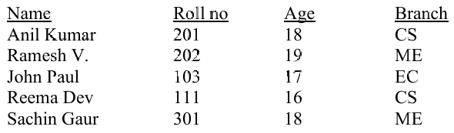
2. Create table called ‘Distributor’ with columns Dcode, Codename, Amount, Limitt and insert the following data.
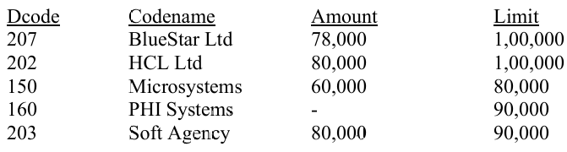
3. Create a table called ‘Agencies’ with columns
Agcode, Agname, Amount, Aglimit and insert the following data into the table
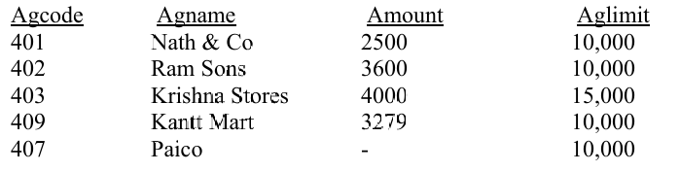

4. Alter the structure of table student by adding a column called Totmarks and insert values into the added field
5. Update the ‘Agencies table, set amount field to 5000 corresponding to Agcode = 403.
6. Delete records from distributor table, whose amount is less than 70,000.
7. Display the Agcode and Agname from table Agencies in reverse order of their amount.
8. Display all Agency names for amount less than 4000 from table ‘Agencies’.
9. Display the student info from student table renaming the fields name as studentname, roll no as student_rollno.
10. Display the student info only in CS.
11. Update the limitt field and amount field of distributor table to 1, 50,000 and 10,000 respectively whose limit is 1,00,000.
12. Display the average of total marks of the students

1.
CREATE TABLE student (
name VARCHAR(50),
rollno INT PRIMARY KEY,
age INT,
branch VARCHAR(10)
);

INSERT INTO student VALUES
('Anil Kumar', 201, 18, 'CS'),
('Ramesh V.', 202, 19, 'ME'),
('John Paul', 103, 17, 'EC'),
('Reema Dev', 111, 16, 'CS'),
('Sachin Gaur', 301, 18, 'ME');
SELECT * FROM student;
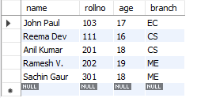
2.
CREATE TABLE distributor (
dcode INT PRIMARY KEY,
codename VARCHAR(50),
amount INT,
limitt INT
);

INSERT INTO distributor VALUES
(207, 'BlueStar Ltd', 78000, 100000),
(202, 'HCL Ltd', 80000, 100000),
(150, 'Microsystems', 60000, 80000),
(160, 'PHI Systems', NULL, 90000),
(203, 'Soft Agency', 80000, 90000);
SELECT * FROM distributor;
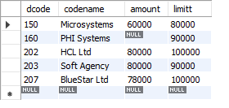
3.
CREATE TABLE agencies (
agcode INT PRIMARY KEY,
agname VARCHAR(50),
amount INT,
aglimit INT
);

INSERT INTO agencies VALUES
(401, 'Nath & Co', 2500, 10000),
(402, 'Ram Sons', 3600, 10000),
(403, 'Krishna Stores', 4000, 15000),
(409, 'Kantt Mart', 3279, 10000),
(407, 'Paico', NULL, 10000);
SELECT * FROM agencies;
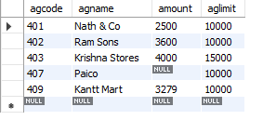
4.
ALTER TABLE student ADD totmarks INT;

UPDATE student SET totmarks = 450 WHERE rollno = 201;
UPDATE student SET totmarks = 480 WHERE rollno = 202;
UPDATE student SET totmarks = 430 WHERE rollno = 103;
UPDATE student SET totmarks = 470 WHERE rollno = 111;
UPDATE student SET totmarks = 490 WHERE rollno = 301;
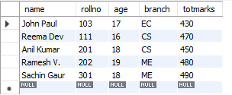
5.
UPDATE agencies SET amount = 5000 WHERE agcode = 403;
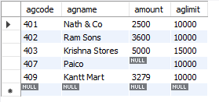
6.
SET SQL_SAFE_UPDATES = 0;
DELETE FROM distributor WHERE amount < 70000;
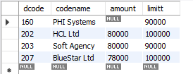
7.
SELECT agcode, agname FROM agencies ORDER BY amount DESC;
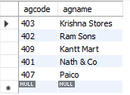
8.
SELECT agname FROM agencies WHERE amount < 4000;
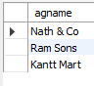
9.
SELECT
name AS studentname,
rollno AS student_rollno,
age,
branch
FROM student;
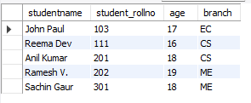
10.
SELECT * FROM student WHERE branch = 'CS';
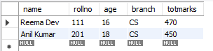
11.
UPDATE distributor
SET limitt = 150000, amount = 10000
WHERE limitt = 100000;
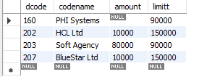
12.
SELECT AVG(totmarks) AS average_marks FROM student;

RESULT
The given SQL commands were successfully executed and the required outputs were obtained.

Experiment 13
FAMILARISATION OF SQL COMMANDS(set 2)
AIM
To study and execute basic SQL DDL and DML commands using MySQL.
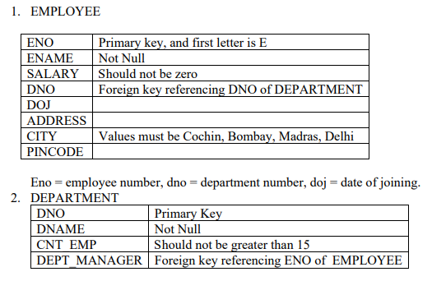
Cnt_emp = employee count
1. Create Tables Employee and department with the corresponding fields and constraints given above and insert values into it.
2. List the name of Employees joined after 1- 1- 1998 and working in department number d1.
3. List all employees working in department other than department number d3.
4. List the name of employees working in department sales.
5. List the name of employees who are not a manager.
6. List the employees whose names starts with ‘J’ and ‘N’ as third character.
7. List all the employees joined during the year 2000.
8. List the name of employees along with their annual salary, and also for each record, get the output,
Every year <ename> earns <amount>
9. Find the total number of employees in employee table.
10. Display the minimum salary of employees in each department.
11. Display the maximum salary of employees in department having average salary greater than 15000.
12. Find the name of employee with minimum salary.
13. List the names of all employees along with the names of departments.
14. List the employee names and their date of joining in format dd/mm/yy

1)
USE DB1;
SET FOREIGN_KEY_CHECKS = 0;
CREATE TABLE EMPLOYEE (
ENO VARCHAR(5) PRIMARY KEY ,
ENAME VARCHAR(30) NOT NULL,
SALARY INT ,
DNO VARCHAR(5),
DOJ DATE,
ADDRESS VARCHAR(50),
CITY VARCHAR(20) ,
PINCODE VARCHAR(10),
FOREIGN KEY (DNO) REFERENCES DEPARTMENT(DNO)
);
CREATE TABLE DEPARTMENT (
DNO VARCHAR(5) PRIMARY KEY,
DNAME VARCHAR(30) NOT NULL,
CNT_EMP INT,DEPT_MANAGER VARCHAR(50),
FOREIGN KEY (DEPT_MANAGER) REFERENCES EMPLOYEE(ENO)
);

INSERT INTO DEPARTMENT VALUES
('d1','Sales',5,'E1'),
('d2','HR',10,'E2'),
('d3','Finance',10,'E3'),
('d4','IT',5,'E1');

SELECT * FROM DEPARTMENT;
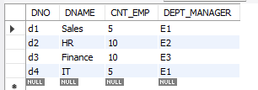
INSERT INTO EMPLOYEE VALUES
('E1','John',18000,'d1','1999-05-12','MG Road','Cochin','682016'),
('E2','Anil',12000,'d2','2000-02-15','Panampilly','Delhi','110001'),
('E3','Neena',22000,'d3','1998-03-18','Marine Drive','Bombay','400001'),
('E4','James',15000,'d1','2000-07-10','Vytilla','Cochin','682019'),
('E5','Nithin',9000,'d4','2000-01-05','Anna Nagar','Madras','600040'),
('E6','Jacob',17000,'d2','1997-08-20','Aluva','Delhi','110002');

SELECT * FROM EMPLOYEE;
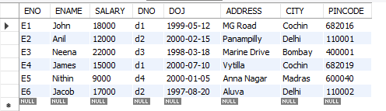

2)
SELECT ENAME
FROM EMPLOYEE
WHERE DOJ > '1998-01-01' AND DNO='d1';
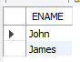

3)
SELECT ENAME
FROM EMPLOYEE
WHERE DNO <> 'd3';
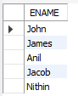

4)
SELECT E.ENAME
FROM EMPLOYEE E, DEPARTMENT D
WHERE E.DNO = D.DNO AND D.DNAME='Sales';

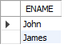
5)
SELECT ENAME
FROM EMPLOYEE
WHERE ENO NOT IN
(SELECT DEPT_MANAGER FROM DEPARTMENT);
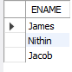

6)
SELECT ENAME
FROM EMPLOYEE
WHERE ENAME LIKE 'J_N%';
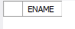
7)
SELECT ENAME
FROM EMPLOYEE
WHERE YEAR(DOJ) = 2000;
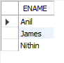
8)
SELECT
ENAME,
SALARY*12 AS ANNUAL_SALARY,
CONCAT('Every year ',ENAME,' earns ',SALARY*12) AS OUTPUT
FROM EMPLOYEE;
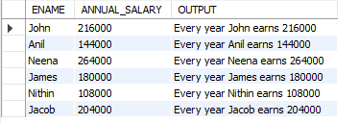
9)
SELECT COUNT(*) AS Cnt_emp
FROM EMPLOYEE;
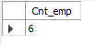
10)
SELECT COUNT(*) AS Cnt_emp
FROM EMPLOYEE;
SELECT DNO, MIN(SALARY) AS MIN_SALARY
FROM EMPLOYEE
GROUP BY DNO;
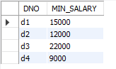
11)
SELECT DNO, MAX(SALARY) AS MAX_SALARY
FROM EMPLOYEE
GROUP BY DNO
HAVING AVG(SALARY) > 15000;
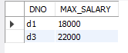
12)
SELECT ENAME
FROM EMPLOYEE
WHERE SALARY = (SELECT MIN(SALARY) FROM EMPLOYEE);
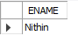
13)
SELECT E.ENAME, D.DNAME
FROM EMPLOYEE E, DEPARTMENT D
WHERE E.DNO = D.DNO;

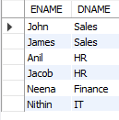
14)
SELECT ENAME, DATE_FORMAT(DOJ,'%d/%m/%y') AS DOJ
FROM EMPLOYEE;
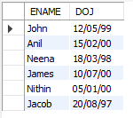

RESULT
The given SQL commands were successfully executed and the required outputs were obtained.

